B.C.M. Sen. Sec. School, Basant City, Pkh. Road, Ludhiana.
Name ___________________ Roll No._____ Standard I
Chapter ( A Smart Machine )
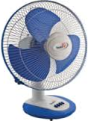
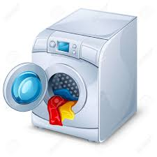
- Look at the pictures shown below very carefully and mark them as E for those which need electricity and N for those which do not need electricity to work.
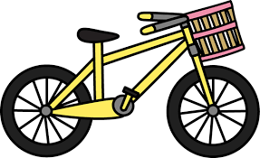
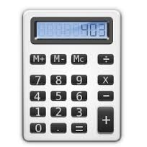

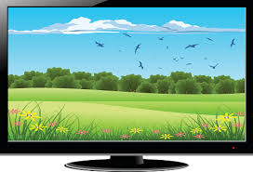
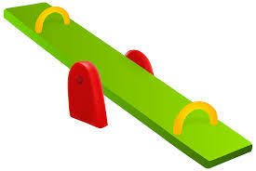
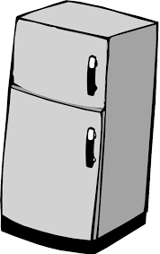
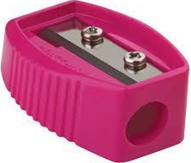

- Answer the following questions:
- What are machines?
Ans. Things made by people.
- What is the benefit of machines?
Ans. Make our work easy.
- Name the machines that work on electricity.
Ans. Fan, AC, TV, Refrigerator
- What is a computer?
Ans. A smart machine
- Name the types of computers.
Ans. Laptop, Tablet
- How many things can a computer do at a time?
Ans. Many things
- Fill in the blanks:
- Sharpener is a machine we use at school.
- Machines save our time.
- Computer never makes mistakes.
- Calculator is a small calculating device.
- Machine makes our work easy.
- State T for true of F for false statement:
  - Human always give correct result.
  - Machines need food to work.
  - Computer remembers many things.
  - Bicycle is a machine.
  - Computer can imagine on its own.
- Identify each picture and write its first letter under the picture to get new word.
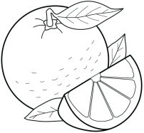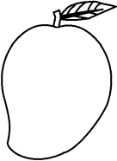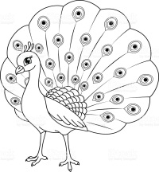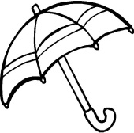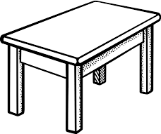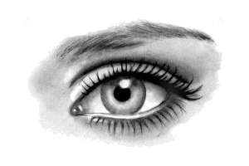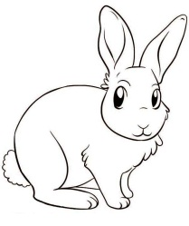
______ ______ ______ ______ ______ ______ ______ ______
- Match the machines to their names. Also colour them.
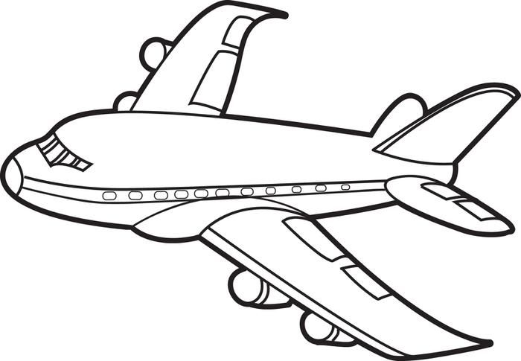 | Nail Cutter
 | Bus
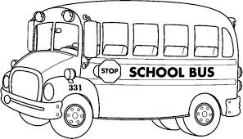 | Aeroplane
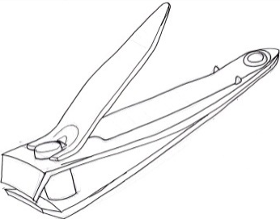 | Stapler
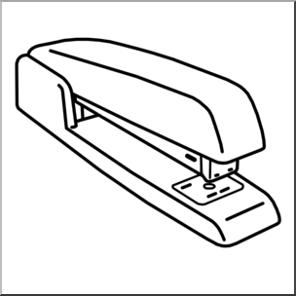 | Knife

